**Classroom Activity​: Write a Function called sum and return total of 2 values​**

**​Code-**

// Define the numbers as constants

const num1 = 5;

const num2 = 10;

function sum() {

return num1 + num2;

}

// Example usage:

const result = sum();

console.log("The sum of " + num1 + " and " + num2 + " is: " + result);

**Output-**

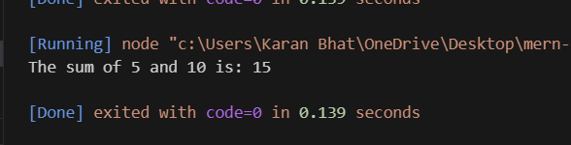

**Execution-Steps:**

* Create a JavaScript file with any name
* Write the code
* Run the code in the terminal using F5 or right click and go to inspect and you can get the output in the console as well.